Biot Motion Tracking System Architecture Description and API Specification

Licence
The MIT License (MIT)
Copyright (c) 2016 Jonathan Kelly
Permission is hereby granted, free of charge, to any person obtaining a copy of this software and associated documentation files (the "Software"), to deal in the Software without restriction, including without limitation the rights to use, copy, modify, merge, publish, distribute, sublicense, and/or sell copies of the Software, and to permit persons to whom the Software is furnished to do so, subject to the following conditions:
The above copyright notice and this permission notice shall be included in all copies or substantial portions of the Software.
THE SOFTWARE IS PROVIDED "AS IS", WITHOUT WARRANTY OF ANY KIND, EXPRESS OR IMPLIED, INCLUDING BUT NOT LIMITED TO THE WARRANTIES OF MERCHANTABILITY, FITNESS FOR A PARTICULAR PURPOSE AND NONINFRINGEMENT. IN NO EVENT SHALL THE AUTHORS OR COPYRIGHT HOLDERS BE LIABLE FOR ANY CLAIM, DAMAGES OR OTHER LIABILITY, WHETHER IN AN ACTION OF CONTRACT, TORT OR OTHERWISE, ARISING FROM, OUT OF OR IN CONNECTION WITH THE SOFTWARE OR THE USE OR OTHER DEALINGS IN THE SOFTWARE.

Considerations
1. The system is currently a prototype undergoing active development.

2. I intend that the ideas, hardware, software and associated documentation developed as part of this project be available for anyone to replicate and use in the spirit of the MIT Software license.

Basically I mean that to mean: if you want to build, implement, experiment with, use, market, make money from, donate expertise in, sell expertise in or modify a system based on this work, you should be free to do so, providing you appropriately acknowledge its source and respect the above intention.

The Purpose of this document

This document defines the basic architecture of the system and specifies a set of APIs that describe how the components should communicate with each other.

Defining the APIs allows for various hardware and software components of the system to be changed and developed without breaking the rest of the system as the modified components will still communicate using the same protocols.

Table of Contents
Licence 1
Considerations 1
The Purpose of this document 2
Document History 4
Overview 5
More Detailed Description 6
The Biot Nodes or 'Biots' 7
The Edge Router (or 'ER') 8
The Biot Broker Application (or 'Broker') 9
The User Interface Application 9
Intended Future Simplification of Structure 10
Specification of Communication Interfaces and behaviours. 11
Biot Node Functionality 11
Edge Router Functionality 11
Biot Broker Functionality 12
Component Interactions 13
Types of Interactions 13
Biot Node communications: 14
Types of Biot Node Messages 15
Biot Node Data Messages 15
Biot Node Control Messages 16
Edge Router communications: 17
Types of Edge Messages 18
Edge Data Messages 18
Edge Control Messages 19
Biot Broker communications: 20
Detailed API and Messaging specifications 21
Biot Message Protocol 21
Biot Messages: 22
List of all Biot commands 22
Orientation: do 23
Calibration: dc 24
Status: ds 25
LED Status: cled 26
Time: ctim 27
DOF: cdof 28
Set Calibration Values: ccav 29
Set Magnetometer Calibration Mode: cmcm 30
Set Data Update Interval: cdup 31
Reboot: creb 32
Poke: cpok 33
Edge Messaging Protocol 34
List of all Edge commands 34
Edge Messages: 36
Orientation: do 36
Calibration: dc 37
Status: ds 38
Identify: cled 39
Synchronise: csyn 40
Set DOF: cdof 41
Set Magnetomer Calibration Values: ccav 42
Set Calibration Mode:cmcm 43
Set Data Update Interval: cdup 44
Reboot: creb 45
Poke: cpok 46
Broker REST API 47
Broker API methods 47
Summary of all API Resources 47
Root Resource 49
Biotz Resource 50
Biotz Count 51
Synchronise Network 52
Biotz Addresses 53
Biotz Node 54
Biotz Orientation Data 55
Biotz All Orientation Data 56
Biotz Health Data 57
Biotz Active Data 58
Biotz Status Data 59
Biotz Calibration Data 60
Biotz Interval Data 61
Biotz LED Data 62
Biotz DOF Data 63
Biotz Magnetometer Calibration Mode 64
Data Storage Categories 65
Data Storage Items 66
Particular Data Storage Item 67
Dummy Biots 68
Dummy Biots 69

Document History
Date | Version | Comments
2016-09-23 | release-v-1.0 | JK
2016-10-13 | release-v-1.1 | JK – minor additions
2016-10-17 | release-v-1.2 | JK – added poke command

Overview

The system is designed to track the physical orientation of objects.

The primary focus is on tracking and recording the movements of human limbs however the system may also be used for a variety of applications where there is a need to measure and record the movements of assemblies of objects.

The system measures individual limb orientation using small sensors attached to each of the limbs (or components) being monitored. Each sensor (called a Biot node or 'Biot' ) contains an Inertial Measurement Unit (IMU) that is used to determine the its current 3 dimensional orientation in space.

Each Biot communicates its orientation to a software interface that collates the information from all the participating Biot Nodes.

A user interface application interacts with the software interface via a REST based Web Servive API to provide features such as:

1. a visual display of the current orientation of the limbs (or components) being tracked.

2. the ability to create and display graphs describing the orientation of limbs and changes in limb orientations over time.

3. the ability to compare orientations and changes in orientation against a previously recorded (or pre defined) set of movements.

4. the ability to export numerical movement data for use with other analytical tools

5. the ability to record the limb movements for later playback and analysis.

Whilst the motivation behind this project is to produce tools that can assist in therapies for people with disabilities or physical injuries, it is not intended that the system be limited to only those kinds of applications.

More Detailed Description
Drawing 1: Components of the System

User
Application(s)

Biot IMU
Node
Biot IMU
Node
Biot IMU
Node
Biot IMU
Node
Biot IMU
Node
Biot IMU
Node
Biot IMU
Node
DODAG
Network

Edge Router
UDP/6LowPan
"Biot" Messages
UDP/IP
"Edge" Messages

TCP/IP HTTP REST
BIOT Broker
Biot Motion Tracking System
PC (or dedicated
device)
PC/Phone/Tablet etc

The Biot Nodes or 'Biots'

The system assumes there will be at least one (and typically a number of) Biot Nodes attached to various limbs (or other objects) whose orientation is to be tracked.

Each Biot is powered by its own battery. A Biot consists of several components all contained on a single small Printed Circuit Board (PCB). The components include:

- an IMU device that uses a combination of tiny electronic gyroscopes, accelerometers and magnetometers that respond to the physical orientation of the Biot node.

- a microprocessor that controls the IMU device and is constantly reading and processing the IMU outputs to generate a mathematical model representation of the node's current orientation.

- a very low power wireless device that can communicate with other components in the system.

- a power and a status LED that by flashing at various rates can be used to indicate the node's connection status and to visually identify itself in response to a request from a user.

The Biots communicate via a 6LowPAN wireless network. 6LowPAN is a wireless network protocol designed for use with very low power wireless devices. Being low power the physical distance a node can reliably communicate over is quite limited however the protocol is designed to be able to dynamically route and relay messages between intermediate neighbouring nodes allowing the network to potentially span greater physical distances than any individual nodes wireless range.

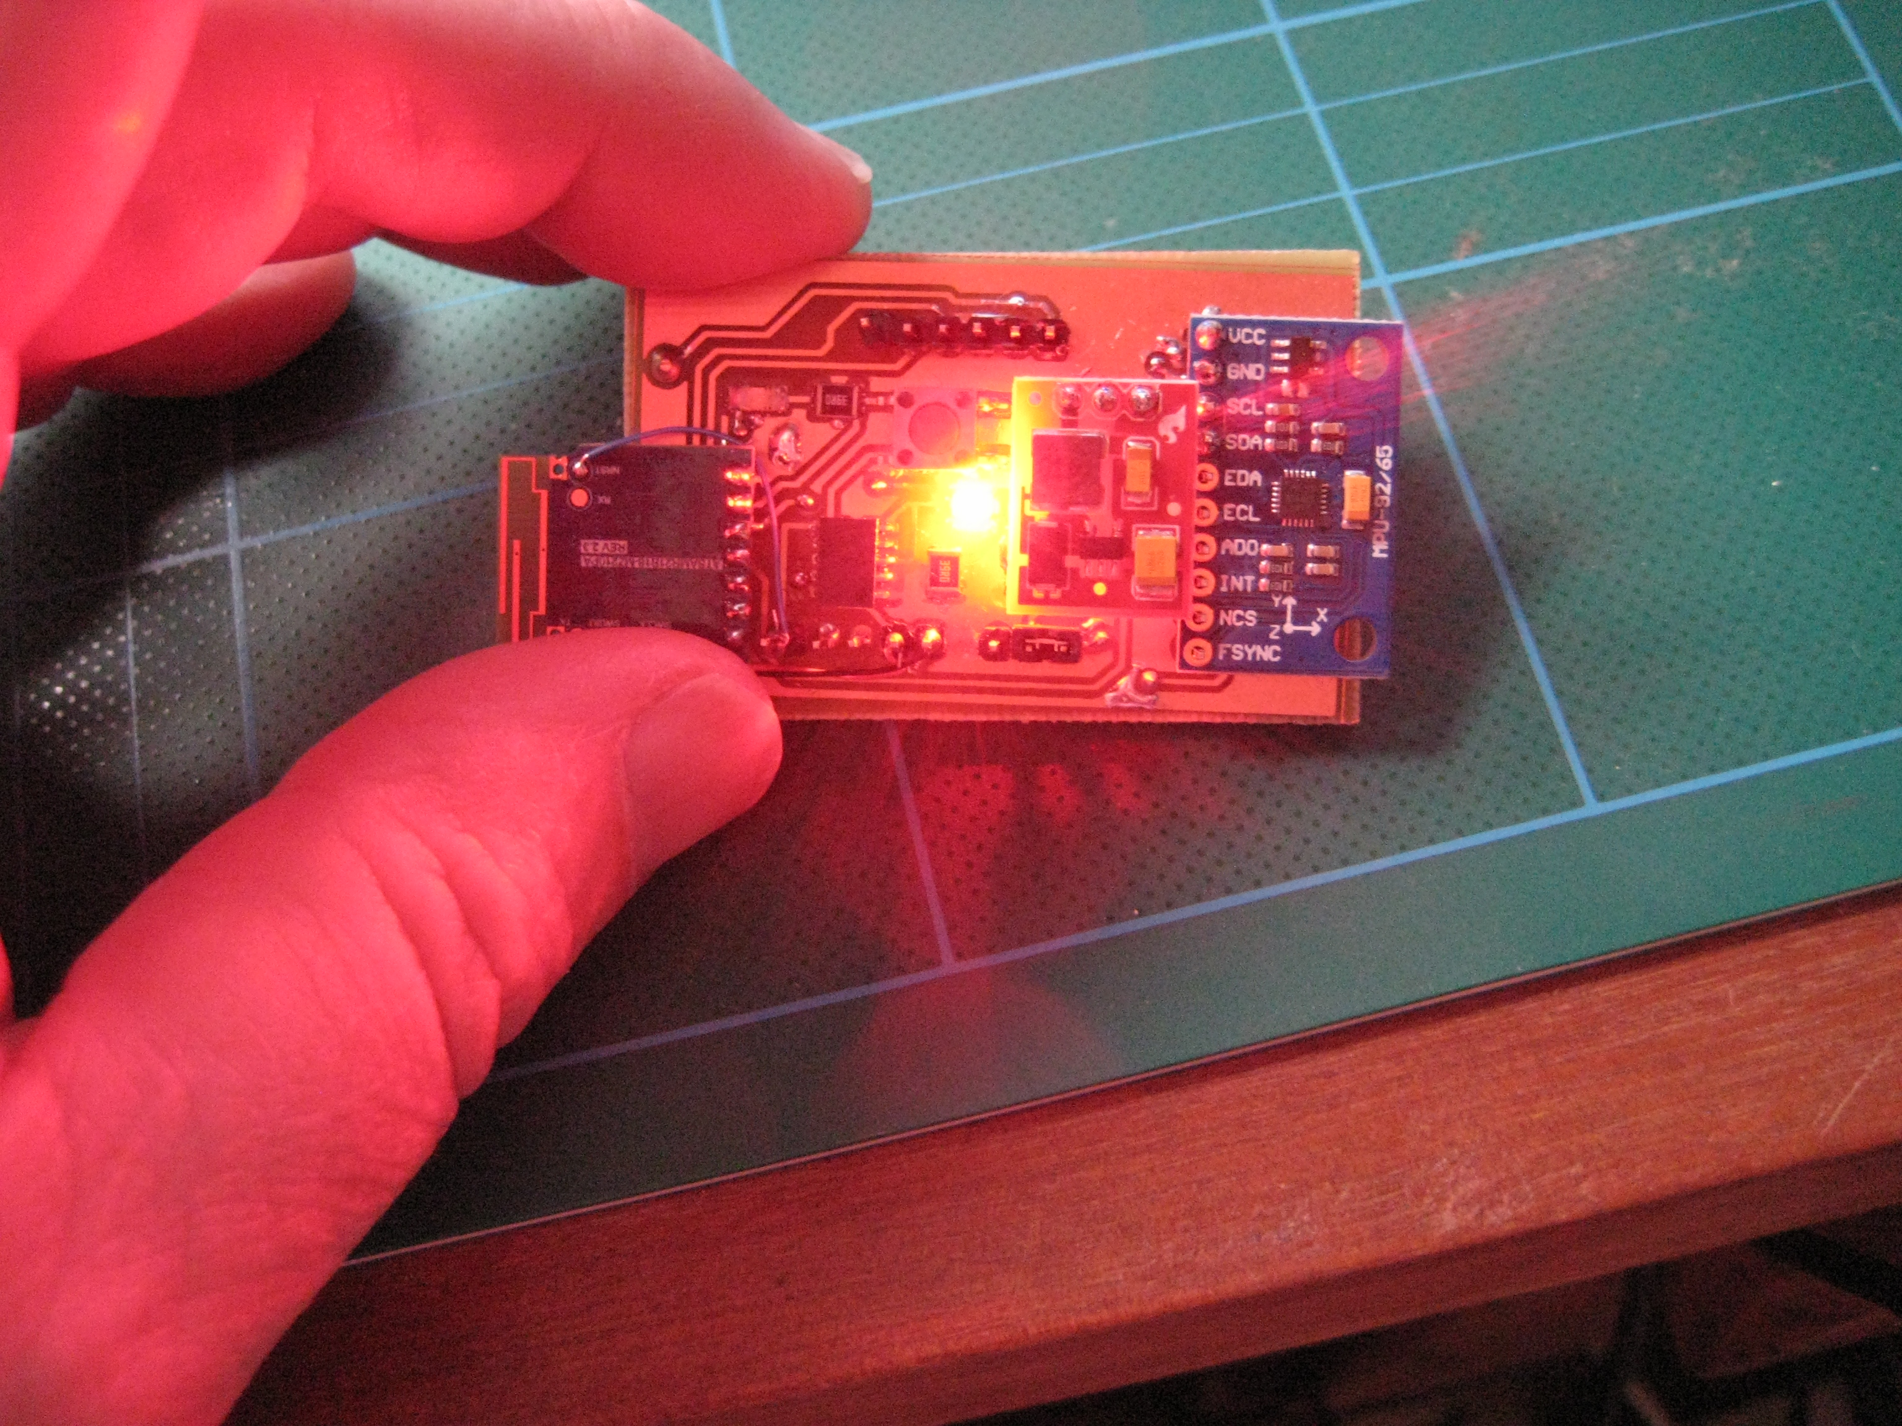
Illustration 1: An early prototype Biot Node

The Edge Router (or 'ER')

The 6LowPAN wireless network has one special node that is a central point to which all Biot data is sent, this special node is called an “Edge Router”. Nodes may communicate directly with the edge router if they are within range or if not can pass data to the edge router via intermediate Biot nodes.

In addition to communicating with the Biots, the Edge Router also has a UDP/IP interface to allow access from conventional network nodes and devices. The Edge Router acts as a gateway between the network of Biots and the wider world.

The Edge Router is a small device that can either be mounted somewhere on the body or nearby to the network of Biot nodes ('nearby' being roughly within 10m-20m).

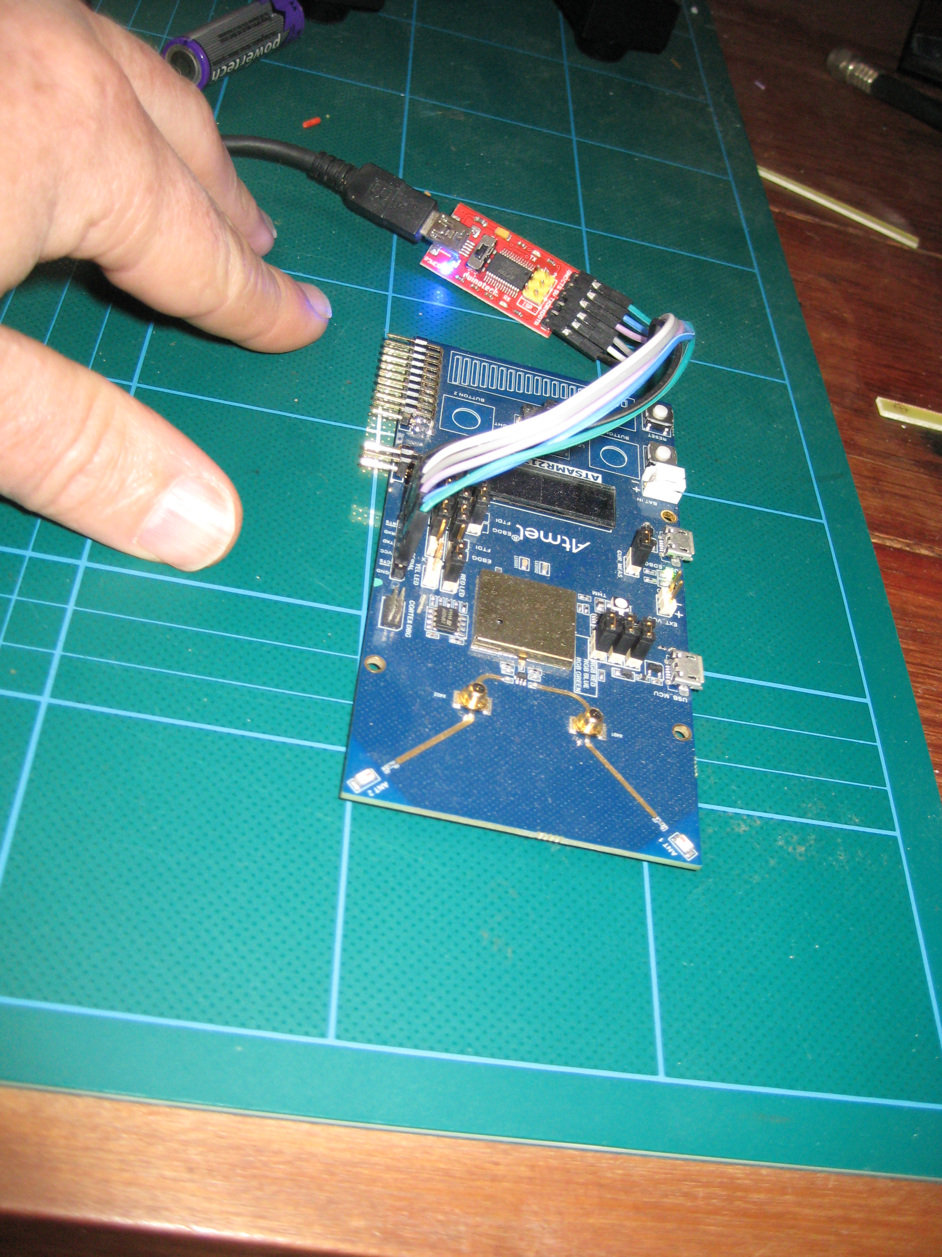
Illustration 2: The prototype Edge Router

The Biot Broker Application (or 'Broker')

The Biot Broker is a software service that sends and receives messages between other applications and the Biot Node network. It talks to both the Edge Router and to other applications (such as a User Interface Application)

The Biot Broker provides a REST Web Service API that UI developers can use to get information about the orientations of the various Biot nodes and to send control requests to the Biot network.

The Broker is a Node JS application that uses the Node Restify module. It currently runs on the same PC as the User Interface however it could potentially be set up to run on the Edge Router at some point in the future.

The User Interface Application

The Biot Broker Web Service API potentially allows a variety of different User Applications to read data from and control the behaviour of the network of Biot Nodes.

The current system implements a User Interface Application that provides a 3D representation of limbs with the ability to control, monitor and record the motions of the limbs. It is implemented as a Browser Based Web Application requiring no special software to be installed on the user's computer and also allowing the UI to be viewed on various devices like phone's, tablets etc.

Currently the UI being included as part of the standard system is a web browser application hosted somewhere that has network connectivity to the Biot Broker application. It uses the Angular2 Application Framework and is written in TypeScript.

Although the system currently provides a default UI, there is nothing to stop anyone writing their own UI applications. Application developers can access the Biot system using the Broker REST API.
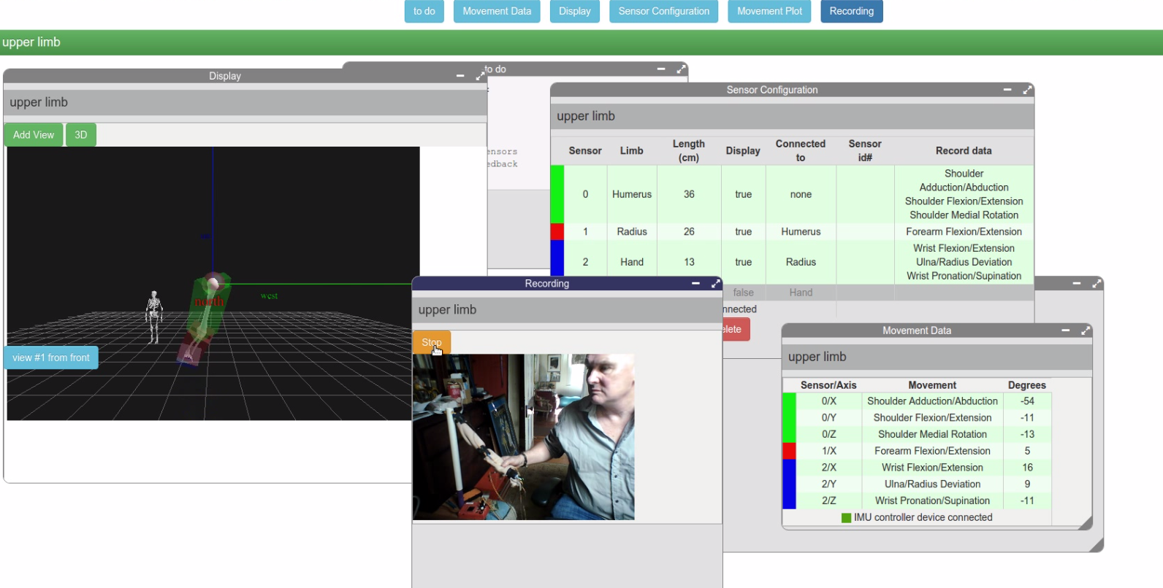
Illustration 3: Early prototype of the User Interface

Intended Future Simplification of Structure

Currently the system is set up using a PC to host both the Broker and the application that provides the UI.

At some point the edge router and the host the Biot Broker runs on should be set up together on a small physical device such as Raspberry Pi or similar. Currently they are implemented as separate systems, with the Biot Broker software running on a PC and the PC connected by cable to the Edge Router device. The software demands of the Biot Broker could be handled by a small device like a Raspberry Pi or similar and this device could also potentially be used to implement the Edge Router.

This device could also provide the web server and host the backend code that provides the UI meaning no special hardware/PC setup outside of the Biot Nodes and the Edge Router device would be required.

This means that once the Biots are connected to a person's limbs and once the combined device (that now would provide the ER and host the Broker and Web Server components) is turned on, user's would just need to go to the Web Address provided by the device to start using the system.

Specification of Communication Interfaces and behaviours.

Biot Node Functionality
Each Node runs the RIOT OS operating system (see: https://riot-os.org/).
Each Node has, for development and diagnostic use, an ATMEL Cortex programming header for updating the firmware and a serial port for connecting a terminal using an FTDI cable. The terminal allows access to a simple command line shell running on the Biot. Normal operations don't require these features to be used.
A node will associate itself with a suitable 6LowPAN Biot network when it detects one.

A node constantly keeps track of its currently calculated orientation.

A node will transmit unbidden its current orientation, calibration values and status at regular intervals to the Edge Router

A node can dynamically calculate and update correction parameters for its magnetometers to account for hard and soft iron errors.

A node can set its magnetometer correction parameters to the values sent to it from the Edge Router (to allow the system to cache calibrations between sessions for faster start up).

A node maintains its own current 'system time'

A node will adjust and synchronise its own system time to be the same as the Edge Router's system time if sent a time value from the edge router.

A node normally blinks its status light every second (using its system time). All nodes that have synchronised to the same system time therefore will blink in unison.

A node can turn its status LED on or off or rapidly flash it for a few seconds to make itself temporarily conspicuous.

Edge Router Functionality
The Edge Router is a device that can communicate on both the 6LowPAN Biot Node Network and a UDP/IP network. It acts as a physical gateway between the Biot Node mesh and the wider world (normally the "wider world" would be a Biot Broker application – see further down for information on the Broker).
The Edge Router acts as the 6LowPAN DODAG Root node.
The Edge router will translate control messages sent from the Broker application and direct them as appropriate to one or more of its Biot nodes.
The Edge Router will translate and pass on data sent to it from Biot nodes to the Broker.
The Edge router will periodically instruct the Biot Nodes in its mesh to synchronise their system time with the ER's system time.

Biot Broker Functionality

The Biot Broker is a software service that provides a REST Based Web Service API to User Applications that wish to obtain data from and to send configuration to, a mesh of Biot Nodes.

The Broker keeps a dynamic cache of Biot Node data built and maintained from any data messages it receives from the Edge Router.

If sent appropriate REST requests from a user application, the Broker can return data on one or more of the Biot Nodes back to the User Application based on the cached information it holds.

If sent appropriate REST requests from a user application, it can construct and send Edge Control requests to the Edge Router to control the Biot Nodes.

Component Interactions

Types of Interactions
There are 3 types of messages/communication protocols between the various components.
1. Biot Node Messages (for communication between the Biots and the ER)
2. Edge Messages (between the ER and the Broker)
3. REST API methods (between User Interfaces and the Broker).
The first 2 protocols (Biot Node and Edge messages) involve sending and consuming messages. The third is a call/response API style interface.
Edge Router
Biot Node
Biot Node
Biot Node
Biot Node
Biot Broker
Application
Biot Node Messages
UDP/6LowPAN
UDP/IP
Edge Messages
data
control
data
control

Biot Node communications:
Biot Node's can only communicate with an Edge Router (or with other Biot Nodes if there is a need to relay messages).
Drawing 2: Biot Node Communications

Biot Node
Biot Node
Biot Node
Biot Node
Biot Node
Edge Router
Biot Node
Messages
(6LowPAN, UDP)
Biot Node Messaging
Biot Node Messages
data
data
data
control
relayed
control
data
data
data
Biot Network

Biot node communications are all UDP using the 6LowPAN protocol. With UDP there is no guarantee of messages being delivered.
The most important data flow in the system is the maintenance of up to date node orientations.
For this reason, rather than the ER sending nodes a request for data and waiting for a response (where there is a risk of the request and/or the associated response being lost), the Biots autonomously (and regularly) push their current orientation (and other) data to the wider system to attempt to keep the system informed about each Biot's current state.

Types of Biot Node Messages
There are 2 categories of Biot Node Messages:
Data Messages and Control Messages.
Data messages are generated by Nodes and directed to the Edge Router..
Control messages come from the Edge Router and are directed to one or more Nodes.
The messages consist of 2 fields (message type and message value) separated by the '#' symbol.

Biot Node Data Messages
Data messages contain either Orientation, Magnetometer Calibration or Status data. They are identified by a 2 character code, for future enhancements, the first character should be the letter 'd' (for data) to help when diagnosing issues.
Examples of Data messages.
Data Message | example | description
Orientation | do#653472:-2.987:0.88:1.1000:0.289 | contains node timestamp and orientation w,x,y,z quaternion values
Calibration | dc#-89:-86:-82:88:3:54 | contains node magnetometer calibration values
Status | ds#111:200:1 | contains IMU DOF settings, the current unsolicited data update time interval and auto calibration mode

Data Messages are sent autonomously from nodes at a rate that is configurable for each node.

Biot Node Control Messages
Control Messages are used to change a Node's behaviour. They can be used to tell a node to:
- adjust its LED display
- adjust its system time
- adjust its IMU DOF settings
- adjust its current calibration parameters
- adjust its frequency of data sending
- reboot itself
They are identified by a 4 character code, for future enhancements, the first character should be the letter 'c' (for control) to assist in diagnosing issues.
Examples of Biot Node Control Messages:
Control Message | example | description
LED display | cled#2 | turn LED off(0), on(1), normal blink(2) or rapid blink(3)
System Time | ctim#653483 | set node system time to given value
Set IMU DOF | cdof#111 | set node gyros, accelerometers, magnetometers on(1) or off(0)
Set Magnetometer Calibration Values | ccav#-89:-86:-82:88:3:54 | Set the node's calibration values
Set Magnetometer Calibration Mode | cmcm#1 | Change auto calibration mode  0:off, 1:on 2:reset and on, 3: reset and off
Set unsolicited data update interval | cdup#200 | set how long a node waits between sending unsolicited node updates (0 = do not send any)
Reboot | creb# | Node should reboot itself

Edge Router communications:
The Edge Router communicates with both Biot Nodes (using 6LowPAN UDP) and the Broker Application (using UDP/IP).
Drawing 3: Edge Router Communications
Edge Router
Biot Node
Biot Node
Biot Node
Biot Node
Biot Broker
Application
Biot Node Messages
UDP/6LowPAN
UDP/IP
Edge Messages
data
control
data
control

Biot Node Messages (UDP/6LowPAN) between the Edge Router and Biot Nodes are described in the previous section (Biot Node Messages).
Communication between the Broker Application and the Edge Router are called "Edge Messages" and consist of text strings sent via UDP/IP. They are similar in format to Biot messages however they have an extra '#' separated field to record the associated Biot IPv6 network address (if applicable).

Types of Edge Messages
As with Biot Node Messages, there are 2 categories of Edge Messages:
Data Messages and Control Messages.
Data messages are generated by the Edge Router and directed to the Broker Application.
Control messages come from the Broker Application and are directed to the Edge Router.
Each message consists of 3 '#' separated fields, the first is the message type, the second the message value and the third an IPv6 network address. Some messages have empty values for the value or address fields.

Edge Data Messages
Data messages contain either Orientation, Magnetometer Calibration or Status data.
Data Messages are constructed and sent autonomously from the Edge Router to the Broker, typically in response to the Edge Router receiving a Node Data Message from a node.
Examples of Edge Data messages.
Data Message | example | description
Orientation | do#12472:-.9:0.8:1.1:0.2#affe::584b:1 | contains a node's IPv6 address and its timestamp and orientation w,x,y,z quaternion values
Calibration | dc#-89:-86:-82:88:3:54#affe::584b:1 | contains a node's address and that node's magnetometer calibration values
Status | ds#111:200:1#affe::584b:1 | contains a node's address and its IMU DOF settings, its current unsolicited data update time interval and its auto calibration mode

Edge Control Messages
Control Messages are used to change the configuration of one or more Biot Nodes belonging to the Edge Router. They are sent from the Biot Broker to the Edge Router.
Examples of Edge Control Messages:
Control Message | example | description
Identify a Node | cled#2#affe::584b:3763:a0ca:1 | turn the LED belonging to the Biot Node with the address 'affe::584b:3763:a0ca:1' off(0), on(1), to normal blink(2) or set to rapid blink(3)
Synchronise all Nodes | sync## | ask edge router to send a ctim message to all its nodes
Set IMU DOF | cdof#111#affe::584b:3763:a0ca:1 | set a node's Gyros, Accelerometers, Magnetometers to on(1) or off(0) (the 3 bits are in the order GAM)
Set Magnetometer Calibration Values | ccav#affe::584b:3763:a0ca:1#-89:-86:-82:88:3:54 | Set a node's calibration values to the ones provided
Set Magnetometer Calibration Mode | cmcm#1#affe::584b:3763:a0ca:1 | Change a node's auto calibration mode to:  0:off, 1:on 2:reset and on, 3: reset and off
Set unsolicited data update interval | cdup#200#affe::584b:3763:a0ca:16" | set how long a node waits between sending unsolicited node updates (0 = do not send any)
Reboot | creb##affe::584b:3763:a0ca:1 | Tell a node to reboot itself

Biot Broker communications:
The Biot Broker provides a TCP/IP REST API to User Applications.
The Biot Broker talks to the Edge Router using UDP/IP Edge Messages.
The Edge messages are described in the previous section. (Edge Router communications).
Biot Broker API commands:
The REST API commands allow user applications to get data about the system (including node orientations) and to adjust the behaviour of the system.
Biot Broker API commands:
Responses will be of the Mime-Type application/json.

Examples of API commands
Method | Example | Description
Root | GET '/' | describes the REST Interface
All Biot Data | GET '/biotz' | get a summary of all active Biots the system has data on
Get Count | GET '/biotz/count' | return a count of known active Biots
Addresses | GET '/biotz/addresses' | return a list of active Biot IPv6 addresses
get all Node data | GET '/biotz/addresses/IPv6_ADDRESS | get details about the Biot with the given address
get Node orientation data | GET '/biotz/addresses/IPv6_ADDRESS/data' | get the orientation quaternion for a given Biot
get current magnetometer calibration | GET '/biotz/addresses/IPv6_ADDRESS/calibration' | get current magnetometer calibration data for a particular Biot
Send a Calibration to a Biot | PUT '/biotz/addresses/IPv6_ADDRESS/calibration' | Sets the calibration of a node to the parameters passed in the request.
Set the Biot LED | PUT '/biotz/addresses/IPv6_ADDRESS/led' | Sets the Biot's LED display to the mode in the passed parameters

Detailed API and Messaging specifications

Biot Message Protocol
The Biot messaging protocol uses UDP/6LowPAN and consists of small text messages.
Each message consists of 2 fields, a short text identifier and a string of associated data.
The field separator is the '#' symbol.
Biot messages can be divided into 2 types, data or control messages. Data messages are sent from Biots, control messages are sent to Biots.
Data message identifiers are 2 characters starting with 'd'. Control message identifiers are 4 characters starting with 'c'.
Being UDP you cannot rely on Biot messages to always arrive at their destination and you will not receive any confirmation of their reception. You also cannot rely on Biot messages to appear at a destination in the sequence they were sent.
For this reason, a stream of Biot data messages are sent regularly by the Biots without being asked.
To determine if a control message was received by a node or may need to be resent, the unsolicited status data messages that are sent by the Biot at regular intervals can be inspected to see how the Biot is currently configured and if the requested changes have been made.

Biot Messages:

List of all Biot commands

Message | Type | Identifier
Orientation | Data | do
Calibration | Data | dc
Status | Data | ds
LED Status | Control | cled
Time | Control | ctim
DOF | Control | cdof
Set Calibration Values | Control | ccav
Set Magnetometer Calibration Mode | Control | cmcm
Set Data Update Interval | Control | cdup
Reboot | Control | creb
Poke | Control | cpok

Orientation: do
 |  | Notes
Message Type | Data
Description | an orientation message is used to describe a spatial orientation. It consists of a system time stamp (to allow the orientation to be correlated with a time) and a Quaternion.
Identifier | do
Format | do#TS:QW:QX:QY:QZ | TS = node system time  QW = node orientation quaternion w component  QX = node orientation quaternion x component  QY = node orientation quaternion y component  QZ = node orientation quaternion z component
Example | do#653472:-2.987:0.88:1.1000:0.289

Comments
A Biot sends orientation messages to the ER on a regular basis. The frequency of sending is controlled by the Biots current Data Update Interval setting.

Calibration: dc
 |  | Notes
Message Type | Data
Description | a calibration message is used to describe the 3 magnetometers envelope of readings. These values indicate how the 3 magnetometers readings deviate from an ideal spherical distribution and can be used to reduce hard and soft iron biases that otherwise distort the magnetometer readings.
Identifier | dc
Format | dc#X0:Y0:Z0:X1:Y1:Z1 | X0 = minimum x-axis value  Y0 = minimum y-axis value  Y0 = minimum z-axis value  X1 = maximum x-axis value  Y1 = maximum x-axis value  Z1 = maximum x-axis value
Example | dc#-89:-86:-82:88:3:54

Comments
A Biot should send calibration messages to the ER on a regular basis. The frequency of sending is controlled by the Biots current Data Update Interval setting. This information can be saved elsewhere in the system and later used to allow the quick set up of the magnetometer calibration of a node after it reboots.
Calibration data is typically sent at 1/100 the frequency of data orientation messages.

Status: ds
 |  | Notes
Message Type | Data
Description | Describes the status of a Biot. It contains the IMU DOF settings, the node's unsolicited data update time interval and the magnetometer auto calibration mode
Identifier | ds
Format | ds#GAM:UI:CM | GAM = the Gyro, Accelerometer, Magnetomer on/off status (0:off, 1:on)  UI = the update interval in system time units  CM = magnetometer calibration mode (0:off, 1:on)
Example | ds#111:200:1 | Gyro, Accelerometer all on, wait 200 time units between sending data updates and auto-calibration is on
Example | ds#010:200:0 | Gyro off, Accelerometer on, Magnetometer off, no data updates to be sent and auto-calibration is off

Comments
A Biot should send status messages to the ER on a regular basis. The frequency of sending is controlled by the Biots current Data Update Interval setting. This information can be used by other parts of the system to verify that the node is in the state requested or expected (particularly as UDP control messages sent by the ER to a node may arrive out of sequence or may be missed altogether by the Biot)
Status data is typically sent at 1/100 the frequency of data orientation messages.

LED Status: cled
 |  | Notes
Message Type | Control
Description | Request to set the LED status of a Node
Identifier | cled
Format | cled#MODE | MODE = 0:off 1:on, 2: standard blink (the default), 3: rapid blink
Example | cled#2 | The node should rapidly blink its LED
Example | cled#0 | The node should turn its LED permanently off

Comment:
If sent a MODE=3 signal (flash rapidly), the node will flash rapidly for several seconds before resuming the default slow flash behaviour (MODE=2). Modes 0 and 1 are intended for development and diagnostic use and should not normally be required or used.

Time: ctim
 |  | Notes
Message Type | Control
Description | Request to set a Biot's system time to the given time value
Identifier | ctim
Format | ctim#VALUE | VALUE = time
Example | ctim#12345 | set the Biot's system time to 12345

Comment

Normally this command is sent by the ER to keep the nodes synchronised to a common time. Biot's on receiving this message adjust their system time to match the given value.

DOF: cdof

 |  | Notes
Message Type | Control
Description | Request to turn the various IMU components on or off.
Identifier | cdof
Format | cdof#GAM | G = gyros off:0, on:1  A = accelerometers off:0, on:1  M = magnetometers off:0, on:1
Example | cdof#100 | turn the Biot's gyros on and accelerometers and magnetometers off

Comment:
The DOF command is designed for development and diagnostic use, it should not normally be required or used as it stops the orientation data from being properly calculated.

Set Calibration Values: ccav

 |  | Notes
Message Type | Control
Description | Request to set a node's magnetometer calibration envelope.
Identifier | ccav
Format | ccav#X0:Y0:Z0:X1:Y1:Z1 | X0 = minimum x-axis value  Y0 = minimum y-axis value  Y0 = minimum z-axis value  X1 = maximum x-axis value  Y1 = maximum x-axis value  Z1 = maximum x-axis value
Example | ccav#-89:-86:-82:88:3:54

Comments

If a magnetometer operated ideally the magnitude of the North Vector measured by the magnetometers would be constant irrespective of the Biot's orientation. The end of the North Vector should always lie on the surface of a sphere centered on the origin.

In real life, magnetometer readings are distorted by soft and hard iron errors due to local magnetic field variations caused by the device's construction, nearby objects, other electronic/electric/magnetised devices etc. The result is the surface the vector traces out is displaced from the origin and the shape is deformed from a perfect sphere.

The envelope values indicate the actual maximum and minimum values encountered in the x, y and z directions allowing the system to calculate how far from the origin and how far from a sphere the readings appear to trace and so correct for these biases.

Set Magnetometer Calibration Mode: cmcm

 |  | Notes
Message Type | Control
Description | Request to turn a node's auto-calibration on/off
Identifier | cmcm
Format | cmcm#MODE | MODE:  0 = stop auto calibration  1 = start or restart auto calibration  2 = reset the calibration envelope and start auto calibration  3 = reset the calibration envelope and stop auto calibration
Example | cmcm#0 | stop auto calibration (eg if you wish the node to stop calculating the calibration envelope).
Example | cmcm#1 | start (or restart) auto calibration (eg if you wish the node to keep adjusting the calibration values as it takes readings).

Comments

In auto calibration mode, the system will update the magnetometer calibration envelope if the system detects any new extreme x, y and z values. If auto calibration is turned off, the envelope will stop being updated. Modes 2 and 3 will reset the envelope values to their un-calibrated state and turn auto calibration on (mode 2) or off (mode 3).

Set Data Update Interval: cdup
 |  | Notes
Message Type | Control
Description | set a Biot's time interval between data updates
Identifier | cdup
Format | cdup#TIME | TIME = time interval (in system time units) to wait between sending the unsolicited data messages.  0 = do not send unsolicited data messages
Example | Cdup#0 | In this example the Biot should stop sending unsolicited data messages
Example | cdup#200 | In this example the Biot should attempt to send data messages every 200 time units

Comments
Unsolicited orientation messages will be sent every update interval. Calibration and Status data messages will be sent less often.
Currently the calibration and status data time interval is set to be 100 times as long as the Data Update Interval meaning there will be 100 orientation messages sent for every calibration or status message sent.

Reboot: creb
 |  | Notes
Message Type | Control
Description | The Biot should reboot itself and resume its normal boot up state.
Identifier | creb
Format | creb# | No data should be sent, just the identifier
Example | creb#

Comments
On receiving this message, the RIOT operating system that is running on the Biot microprocessor should reboot itself. This will set the Biot back to its default configuration, including wiping magnetometer calibrations, resetting the system time and restarting the network system etc

After rebooting, it may take several seconds before the Biot becomes appropriately registered on the 6LowPAN network again and thus before it is available to participate in the system again.

Poke: cpok
 |  | Notes
Message Type | Control
Description | "Poke" command. The Biot should send status and calibration information at its earliest convenience.
Identifier | cpok
Format | cpok# | No data should be sent, just the identifier
Example | cpok#

Comments
On receiving this message, the biot should fire off a status and calibration response. This command is used to attempt to force status responses from the biot outside of its normal schedule.

Edge Messaging Protocol
The Edge messaging Protocol uses UDP/IP.

In a similar way to Biot messages, Edge messages can be divided into 2 types, data or control messages. Data messages are sent from the ER, control messages are sent to the ER.
Most Edge messages have a matching message in the Biot Message API.

The main difference between Biot and Edge messages is that Edge messages usually need to include a network address to indicate either: the Biot node the message comes from or the Biot the data should be sent to.

Edge messages are therefore of a similar format to Biot messages but with an address field added to them (they use the same '#" symbol as the field separator).
eg

ds#111:200:1#affe::584b:3763:a0ca:19b6

which is a message that has an identifier 'ds', a value of 111:200:1 and a node address of affe::584b:3763:a0ca:19b6

List of all Edge commands
Message | Type | Identifier
Orientation | Data | do
Calibration | Data | dc
Status | Data | ds
Identify | Control | cled
Synchronise | Control | csyn
DOF | Control | dof
Set Calibration Values | Control | ccav
Set Magnetometer Calibration Mode | Control | cmcm
Set Data Update Interval | Control | cdup
Reboot | Control | creb
Poke | Control | cpok

Edge Messages:

Orientation: do
 |  | Notes
Message Type | Data
Description | Contains orientation data from a specified Biot
Identifier | do
Format | do#ORIENTATION#IPv6-ADDRESS | The ORIENTATION value will be in the same form as in the corresponding Biot API Orientation message.
Example | do#6532:-.987:0.88:1.1000:0.289#affe::584b:3763:a0ca:1
Behaviour | This message is sent from the ER to the Broker whenever the ER receives an orientation Biot message from a Biot.

Comments

The network address is the address of the Biot that the orientation data came from.

Calibration: dc
 |  | Notes
Message Type | Data
Description | Contains calibration data from a specified Biot
Identifier | dc
Format | dc#CALIBRATION#IPv6-ADDRESS | The CALIBRATION value will be in the same form as the corresponding Biot API Calibration message.
Example | dc#6532:-.987:0.88:1.1000:0.289#  affe::584b:3763:a0ca:1
Behaviour | This message is sent from the ER to the Broker whenever the ER receives a calibration Biot message from a Biot.

Comments
The address is the network address of the Biot Node that the calibration data came from.

Status: ds
 |  | Notes
Message Type | Data
Description | Contains status data from a specified Biot
Identifier | dc
Other properties | dc#STATUS#IPv6-ADDRESS | The STATUS value will be in the same form as the corresponding Biot API Status message.
Example | ds:111:200:1#affe::584b:3763:a0ca:1
Behaviour | This message is sent from the ER to the Broker whenever the ER receives a status Biot message from a Biot.

Comments
The network address is that of the Biot Node that the status data came from.

Identify: cled
 |  | Notes
Message Type | Control
Description | Set the behaviour of a Biot Status LED
Identifier | cled
Format | cled#MODE#IPv6-ADDRESS | MODE  0 = off  1= on  2 = normal blink (default)  3 = rapid blink
Example | cled:2#affe::584b:3763:a0ca:1
Behaviour | When this message is received by the ER, it should send a “cled” Biot message to the specified Biot.

Comments

If sent a MODE=3 signal (flash rapidly), the node will flash rapidly for several seconds before resuming the default slow flash behaviour (MODE=2).

Modes 0 and 1 are intended for development and diagnostic use and should not normally be required or used.

A control message to set a Biots LED status to MODE=3 can be used to assist in visually identifying that Biot because of its rapid flash rate.

Synchronise: csyn
 |  | Notes
Message Type | Control
Description | Ask the ER to sent a time control messsage to all its Biot nodes. This should cause them to adopt that system time as their own.
Identifier | csyn
Format | csyn##
Example | csyn##
Behaviour | When this message is received by the ER, it will send a “csyn” Biot message to all the Biots the ER knows.

Comments

Once all nodes are synchronised with the ER's system time, the LED status “heartbeat” blink should occur at the same time for all nodes, indicating their active participation in the ER's DODAG network.

An out of sync “heartbeat” from a Biot's LED indicates the Biot is not properly participating in the system.

Set DOF: cdof
 |  | Notes
Message Type | Control
Description | Tell a Biot to adjust the status of its Gyroscopes, Accelerometers and or Magnetometers. Similar to the Biot Command defined above but requires a Node address so the ER knows where to send the command
Identifier | cdof
Format | cdof#GAM#IPv6_ADDRESS | G = gyros off:0, on:1  A = accelerometers off:0, on:1  M = magnetometers off:0, on:1
Example | cdof#111#affe::584b:3763:a0ca:1
Behaviour | When the ER receives this message it should send a “cdof” Biot message to the appropriate Biot.

Comments
The DOF command is designed for development and diagnostic use, it should not normally be required or used as disabling any DOF will stop the orientation data from being properly calculated.

Normally all DOFs are active (ie mode 111).

Set Magnetomer Calibration Values: ccav
 |  | Notes
Message Type | Control
Description | Tell a Biot to use the given magnetometer calibration envelope. Similar to the Biot “ccav” command defined above but it requires a Node address so the ER knows where to send the command
Identifier | ccav
Format | ccav#X0:Y0:Z0:X1:Y1:Z1#IPv6_ADDRESS | X0 = minimum x-axis value  Y0 = minimum y-axis value  Y0 = minimum z-axis value  X1 = maximum x-axis value  Y1 = maximum x-axis value  Z1 = maximum x-axis value
Example | ccav#-89:-86:-82:88:3:54#affe::584b:3763:a0ca:1
Behaviour | When the ER receives this message it should send a “ccav” Biot message to the specified Biot.

Comments

If a magnetometer operated ideally the magnitude of the North Vector measured by the magnetometers would be constant irrespective of the Biot's orientation. The end of the North Vector should always lie on the surface of a sphere centered on the origin.

In real life, magnetometer readings are distorted by soft and hard iron errors due to local magnetic field variations caused by the device's construction, nearby objects, other electronic/electric/magnetised devices etc. The result is the surface the vector traces out is displaced from the origin and the shape is deformed from a perfect sphere.

The envelope values indicate the actual maximum and minimum values encountered in the x, y and z directions allowing the system to calculate how far from the origin and how far from a sphere the readings appear to trace and so correct for these biases.

Set Calibration Mode:cmcm
 |  | Notes
Message Type | Control
Description | Request to turn a node's auto-calibration on/off
Identifier | cmcm
Format | cmcm#MODE#IPv6_ADDRESS | MODE:  0 = stop auto calibration  1 = start or restart auto calibration  2 = reset the calibration envelope and start auto calibration  3 = reset the calibration envelope and stop auto calibration
Example | cmcm#0#affe::584b:3763:a0ca:1 | stop auto calibration (eg if you wish the node to stop calculating the calibration envelope).
Example | cmcm#1#affe::584b:3763:a0ca:1 | start (or restart) auto calibration (eg if you wish the node to keep adjusting the calibration values as it takes readings).
Behaviour | When the ER receives this message it should send a “cmcm” Biot message to the specified Biot.

Comments

In auto calibration mode, a Biot will update the magnetometer calibration envelope with any new extreme x, y and z values. If auto calibration is turned off, the envelope will stop being updated. Modes 2 and 3 will actually reset the envelope values to their un-calibrated state and then turn auto calibration on or off as indicated in the table.

Set Data Update Interval: cdup
 |  | Notes
Message Type | Control
Description | Request to set the time interval between data updates
Identifier | cdup
Format | cdup#TIME#IPv6_ADDRESS | TIME = time interval (in system time units) to wait between sending the unsolicited data messages.  0 = do not send unsolicited data messages
Example | cdup#0#affe::584b:3763:a0ca:1 | tell node it node should stop sending unsolicited data messages
Example | cdup#200#affe::584b:3763:a0ca:1 | tell node it should attempt to send data messages every 200 time units
Behaviour | When the ER receives this message it should send a “cdup” Biot message to the specified Biot.

Comments
A Biot's unsolicited orientation messages will be sent every update interval. Calibration and Status data messages will be sent less often.
Currently the calibration and status data time interval is set to be 100 times as long as the Data Update Interval meaning there will be 100 orientation messages sent for every calibration or status message sent.

Reboot: creb
 |  | Notes
Message Type | Control
Description | The Biot should reboot itself and resume its normal boot up state.
Identifier | creb
Format | creb##IPv6_IDENTIFIER | No data should be sent, just the identifier and node address
Example | creb##affe::584b:3763:a0ca:1
Behaviour | When the ER receives this message it should send a “creb” Biot message to the specified Biot.

Comments
After a Biot node reboots, it may take several seconds before a Biot becomes appropriately registered on the 6LowPAN network again thus before it is available to participate in the system again.

Poke: cpok
 |  | Notes
Message Type | Control
Description | The Biot should send a status and calibration message irrespective of where it is at in its cycle
Identifier | cpok
Format | cpok##IPv6_IDENTIFIER | No data should be sent, just the identifier and node address
Example | cpok##affe::584b:3763:a0ca:1
Behaviour | When the ER receives this message it should send a “cpok” Biot message to the specified Biot.

Comments
Used to try and force a Biot node to send status and calibration data outside of its normal schedule.

Broker REST API
The Biot Broker allows Applications to interact with the Biot System via a TCP/IP HTTP REST web service.
The Broker listens and responds to REST requests from User Applications and communicates with the Edge Router by sneding and receiving UDP/IP Edge messages.

The REST URL interface is divided into several sets of resources, the major ones being:
1. Biot resources
2. Storage resources
Biot Resources are concerned with the Biots themselves, their configuration and orientation and how they are connected to limbs (or other objects).
Storage resources are concerned with giving applications the ability to store and retrieve data (such as Biot calibrations, details on assemblies of limbs, application settings etc) between sessions.

Broker API methods

Summary of all API Resources
Resource | Description
General Utility resources
GET '/' | Return an overview of Resources available in the API
GET '/biotz' | Return a list of active Biots in the system
GET '/biotz/count' | Return a count of active Biots
PUT '/biotz/synchronise' | Tell the ER to synchronise all Biots
GET '/biotz/addresses' | Return a list of active Biot addresses
Specific Biot resources
GET '/biotz/addresses/IPv6_ADDRESS | Return a summary of a particular Biot
GET '/biotz/addresses/IPv6_ADDRESS/data' | Return a particular Biot's orientation data
GET '/biotz/addresses/IPv6_ADDRESS/calibration' | Return a particular Biot's Calibration envelope
GET '/biotz/addresses/IPv6_ADDRESS/status' | Return a particular Biot's configuration status
GET '/biotz/addresses/IPv6_ADDRESS/led | Get a Biot's LED mode
PUT '/biotz/addresses/IPv6_ADDRESS/led | Set a particular Biot's LED mode
GET '/biotz/addresses/IPv6_ADDRESS/dof | Get a Biot's current DOF settings
PUT '/biotz/addresses/IPv6_ADDRESS/dof | Change a Biot's DOF settings
GET '/biotz/addresses/IPv6_ADDRESS/interval | Get a Biot's Update Interval
PUT '/biotz/addresses/IPv6_ADDRESS/interval | Change a Biot's update interval
GET '/biotz/addresses/IPv6_ADDRESS/auto | Get a Biot's calibration mode
PUT '/biotz/addresses/IPv6_ADDRESS/auto | Change a Biot's calibration mode
Data Storage
GET '/data' | Return a list of known categories for which data is held
GET '/data/:category' | Return a list of known resources that exist in a given category
GET '/data/:category/:name' | Return a specific resource
PUT '/data/:category/:name' | Save a resource
DELETE '/data/:category' | Remove a category
DELETE '/data/:category/:name' | Remove an item
Dummy Biot Resources | (intended for system testing, development and diagnostic use only)
GET '/devel/dummybiots | Get a list of all dummy nodes
PUT '/devel/dummybiots/IPv6_ADDRESS | Create a new Dummy Biot node with the given address
DELETE '/devel/dummybiots | Delete all dummy Biots
DELETE '/devel/dummybiots/IPv6_ADDRESS | Delete a specific dummy Biot

As a general rule, any successful call will return a 200 status code and a response body with some text.
Response bodies will typically be JSON

Root Resource
Root Resource
Description | Returns an overview of Resources available in the API
Method | GET
URL | /
Example
Request | GET / HTTP/1.1
Response | HTTP/1.1 200 OK  {  "title": "Biotz Broker REST API",  "description": "Interface to a network of Biot Orientation Sensors",  "version": "0.1",  "links": [  "http://localhost:8889/",  "http://localhost:8889/biotz",  "http://localhost:8889/data"  ]  }

Biotz Resource
Biotz Resource
Description | Returns an summary of Active Biots
Method | GET
URL | /biotz
Example
Request | GET /biotz HTTP/1.1
Response | HTTP/1.1 200 OK  {  "count":3,  "addresses":[  "affe::594a:1455:ff12:f9f2",  "affe::594c:1c57:5786:21b2",  "affe::5942:376a:83b:b8d6"  ]  }

Biotz Count
Count Biots
Description | Return a count of Active Biots
Method | GET
URL | /biotz/count
Example
Request | GET /biotz/count HTTP/1.1
Response | HTTP/1.1 200 OK  "3"

Synchronise Network
Synchronise Network
Description | Attempt to force all Biots to synchronise with the ER
Method | PUT
URL | /biotz/synchronise
Example
Request | PUT /biotz/synchronise HTTP/1.1
Response | HTTP/1.1 200 OK  "OK"

Biotz Addresses
Biotz Addresses
Description | Return the IPv6 addresses of known Biots
Method | GET
URL | /biotz/addresses
Example
Request | GET /biotz/addresses HTTP/1.1
Response | HTTP/1.1 200 OK  [  "affe::594a:1455:ff12:f9f2",  "affe::594c:1c57:5786:21b2",  "affe::5942:376a:83b:b8d6"  ]

Biotz Node
Specific Biot Resource
Description | Return details of a Biot Node
Method | GET
URL | /biotz/addresses/:address
Example
Request | GET /biotz/addresses/affe::594a:1455:ff12:f9f2 HTTP/1.1
Response | HTTP/1.1 200 OK  {  "data":"48400:0.929597:0.306609:-0.019845:-0.203584",  "calibration":"-119:-45:-421:313:275:0"},  "status":"111:200:1",  "interval":"200",  "auto":"1",  "dof":"111",  "led":"2"  }

Biotz Orientation Data
Biot Orientation
Description | Return details of the orientation of a Biot Node
Method | GET
URL | /biotz/addresses/:address/data
Example
Request | GET /biotz/addresses/affe::594a:1455:ff12:f9f2/data HTTP/1.1
Response | HTTP/1.1 200 OK  "48400:0.929597:0.306609:-0.019845:-0.203584"

Biotz All Orientation Data
Biot Orientation
Description | Return details of the orientation of all known Biot Nodes
Method | GET
URL | /biotz/all/data
Example
Request | GET /biotz/all/data HTTP/1.1
Response | HTTP/1.1 200 OK  {  "affe::594c:3056:1225:a2c6":"5875:0.053442:-0.945348:-0.313422:-0.072303",  "affe::594a:1455:ff12:f9f2":"23700:0.271692:0.019793:0.150931:0.950269"  }

Biotz Health Data
Biot Orientation
Description | Return details of the health of a Biot Node
Method | GET
URL | /biotz/addresses/:address/alive
Example
Request | GET /biotz/addresses/affe::594a:1455:ff12:f9f2/alive HTTP/1.1
Response | HTTP/1.1 200 OK  {  "ts":"2016-10-13T02:00:14.002Z",  "status":"active"  }

Biotz Active Data
Biot Orientation
Description | Return if Biot is active/inactive or not responding
Method | GET
URL | /biotz/addresses/:address/alive/status
Example
Request | GET /biotz/addresses/affe::594a:1455:ff12:f9f2/alive/status HTTP/1.1
Response | HTTP/1.1 200 OK  "active"

Biotz Status Data
Biot Status
Description | Return details of the configuration status of a Biot Node
Method | GET
URL | /biotz/addresses/:address/status
Example
Request | GET /biotz/addresses/affe::594a:1455:ff12:f9f2/status HTTP/1.1
Response | HTTP/1.1 200 OK  "111:200:1"

Biotz Calibration Data
Biot Calibration
Description | Get/Set the magnetometer calibration envelope of a Biot Node
Method | GET/PUT
URL | /biotz/addresses/:address/calibration
Example | Get current value
Request | GET /biotz/addresses/affe::594a:1455:ff12:f9f2/calibration HTTP/1.1
Response | HTTP/1.1 200 OK  "-267:0:-428:72:123:0"
Example | Set new value
Request | PUT /biotz/addresses/affe::594a:1455:ff12:f9f2/calibration HTTP/1.1  -262:10:-401:66:120:24
Response | HTTP/1.1 200 OK  "OK"

Biotz Interval Data
Biot Status
Description | Get/Set the current update interval value
Method | GET/PUT
URL | /biotz/addresses/:address/interval
Example | Get current value
Request | GET /biotz/addresses/affe::594a:1455:ff12:f9f2/interval HTTP/1.1
Response | HTTP/1.1 200 OK  "321"
Example | Set new value
Request | PUT /biotz/addresses/affe::594a:1455:ff12:f9f2/interval HTTP/1.1  123
Response | HTTP/1.1 200 OK  "OK"

Biotz LED Data
Biot Status
Description | Get/Set the current LED mode
Method | GET/PUT
URL | /biotz/addresses/:address/led
Example | Change DOF setting
Request | PUT /biotz/addresses/affe::594a:1455:ff12:f9f2/led HTTP/1.1  3
Response | HTTP/1.1 200 OK  "OK"
Example | Get current DOF setting
Request | GET /biotz/addresses/affe::594a:1455:ff12:f9f2/led HTTP/1.1
Response | HTTP/1.1 200 OK  "2"

Biotz DOF Data
Biot Status
Description | Get/Set the current Gyro/Accel/Magnetometer on/off setting
Method | GET/PUT
URL | /biotz/addresses/:address/dof
Example | Change DOF setting
Request | PUT /biotz/addresses/affe::594a:1455:ff12:f9f2/dof HTTP/1.1  101
Response | HTTP/1.1 200 OK  "OK"
Example | Get current DOF setting
Request | GET /biotz/addresses/affe::594a:1455:ff12:f9f2/dof HTTP/1.1
Response | HTTP/1.1 200 OK  "101"

Biotz Magnetometer Calibration Mode
Biot Status
Description | Get/Set the current magnetometer calibration mode
Method | GET/PUT
URL | /biotz/addresses/:address/auto
Example | Set mode
Request | PUT /biotz/addresses/affe::594a:1455:ff12:f9f2/auto HTTP/1.1  1
Response | HTTP/1.1 200 OK  "OK"
Example | Get current mode
Request | GET /biotz/addresses/affe::594a:1455:ff12:f9f2/auto HTTP/1.1
Response | HTTP/1.1 200 OK  "1"

Data Storage Categories
Data Storage
Description | Get a list of categories that have been used
Method | GET
URL | /data
Example
Request | GET /data HTTP/1.1
Response | HTTP/1.1 200 OK  [  "calibrations",  "assemblies",  "limbs",  "configurations"  ]

Comments:

The Data Storage Methods allow applications to store and retrieve data between sessions. They act like a simple file storage system. The "category" property is similar to a directory or folder and the "name" property is equivalent to the name of the file. Data to be stored is sent in the body of the PUT request.

Data Storage Items
Data Storage
Description | Get a list of items that exist in a category
Method | GET/DELETE
URL | /data/:category
Example
Request | GET /data/calibrations HTTP/1.1
Response | HTTP/1.1 200 OK  [  "affe::594a:1455:ff12:f9f2",  "affe::594c:1c57:5786:21b2",  "affe::5942:376a:83b:b8d6"  ]
Request | GET /data/limbs HTTP/1.1
Response | HTTP/1.1 200 OK  [  "femur",  "tibia",  "pelvis"  ]
Example | Delete a Category
Request | DELETE /data/calibrations HTTP/1.1
Response | HTTP/1.1 409 Conflict  "category contains items and cannot be deleted, delete items first"
Example | Delete a Category
Request | DELETE /data/emptyAndUnwantedCategory HTTP/1.1
Response | HTTP/1.1 200  "OK"
Comments:

You cannot DELETE a category if it contains items.

Particular Data Storage Item
Stored Item
Description | Get/Put a stored item
Method | GET/PUT
URL | /data/:category/:name
Example | Get saved item
Request | GET /data/calibrations/affe::594a:1455:ff12:f9f2 HTTP/1.1
Response | HTTP/1.1 200 OK  "-262:10:-401:66:120:24"
Example | Save new item
Request | PUT /data/limbs/femur HTTP/1.1  {"length":"24","vertices":"/data/models/femur.json"}
Response | HTTP/1.1 200 OK  "OK"
Example | Get saved item
Request | GET /data/limbs/femur HTTP/1.1
Response | HTTP/1.1 200 OK  {  "length":"24",  "vertices":"/data/models/femur.json"  }

Comments:

if you PUT an item in a category that doesn't exist, the category it will be created.

Dummy Biots
Dummy Nodes
Description | Create Dummy Biot Nodes for development/testing/diagnostics
Method | PUT/DELETE
URL | /devel/dummybiots/:address
Example | Create Dummy Biot
Request | PUT /devel/dummybiots/affe::002 HTTP/1.1
Response | HTTP/1.1 200 OK  "OK"
Example | Delete Dummy Biot
Request | DELETE /devel/dummybiots/affe::002 HTTP/1.1
Response | HTTP/1.1 200 OK  "OK"

Comments:

Dummy Biot Nodes are used for development and testing, they would not normally be used otherwise.

Dummy Biots
Dummy Nodes
Description | all Dummy Biot Nodes
Method | GET/DELETE
URL | /devel/dummybiots
Example | List all Dummy Biots
Request | GET /devel/dummybiots
Response | HTTP/1.1 200 OK  [  "affe::001",  "affe::002",  "affe::003",  ]
Example | Delete all Dummy Biots
Request | DELETE /devel/dummybiots
Response | HTTP/1.1 200 OK  "OK"

Comments:

Dummy Biot Nodes are used for development and testing, they would not normally be used otherwise.

